**GitHub repository link: -**

**https://github.com/GayashanDeshapriya/DL-Lab08-IT21156656.git**

## Question 1: Markov Decision Process and Q-Learning

1. 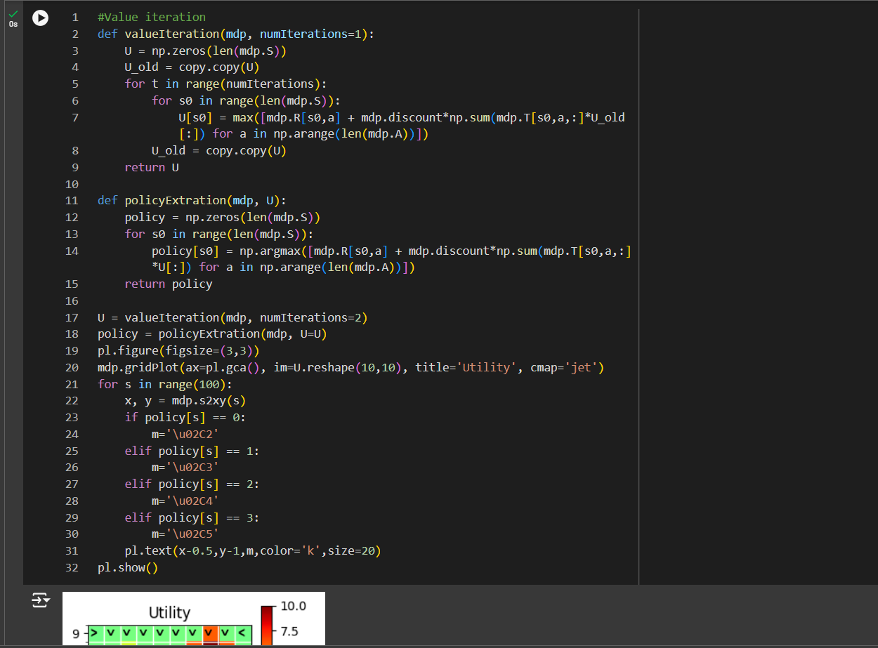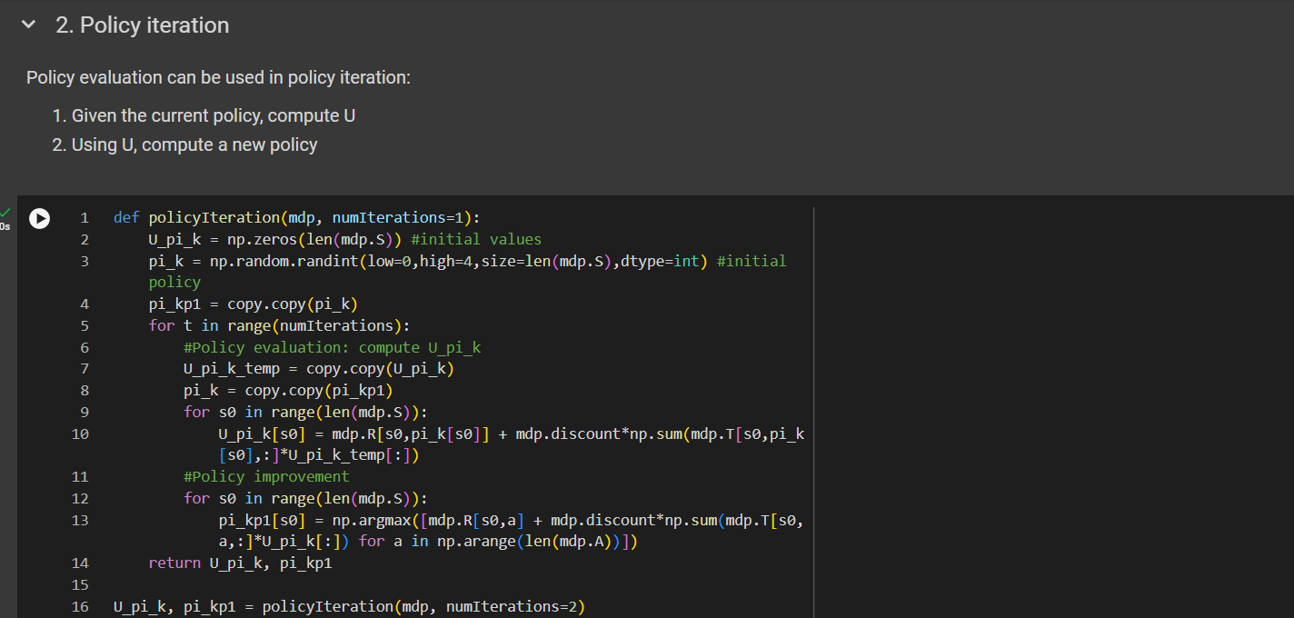Policy Evaluation

## Question 2: Model-Based vs Model-Free Reinforcement Learning

### Difference Between Model Based and Model Free Algorithms

|  |  |
| --- | --- |
| Model Based Algorithms | Model Free Algorithms |
| Explicitly learns a model of the environment | Does not learn a model of the environment; learns from direct interaction with the environment. |
| Typically converges faster when the model is accurate. | Converges slower, especially in complex environments. |
| Uses the learned model to simulate and plan actions, allowing foresight | Learns directly from trial and error without planning ahead. |
| More sample-efficient since it can plan by simulating many possible outcomes. | Less sample-efficient, relies on more interactions with the environment to improve |

## Question 3: Introduction to Deep Q-Learning (DQN)

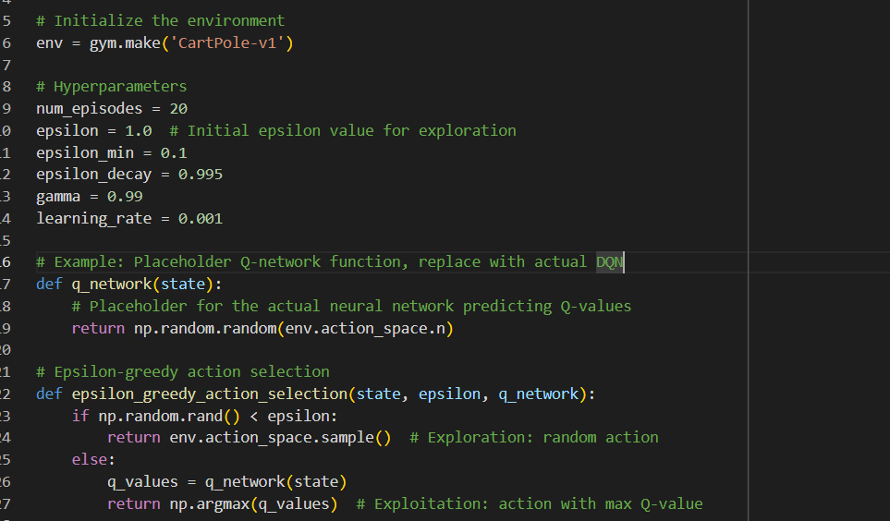 For Epsilon Val: 0.1

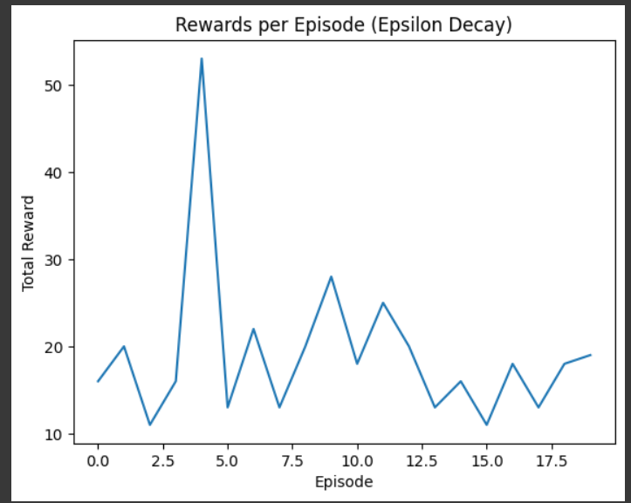

For Epsilon Value 0.5

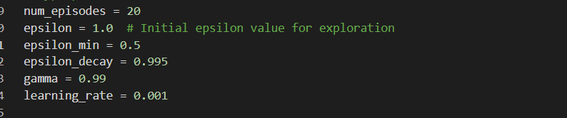

Foe Epsilon Value 0.9

# Gridworld.ipynb Changes

